An 8-measure melody with two, 4-measure phrases
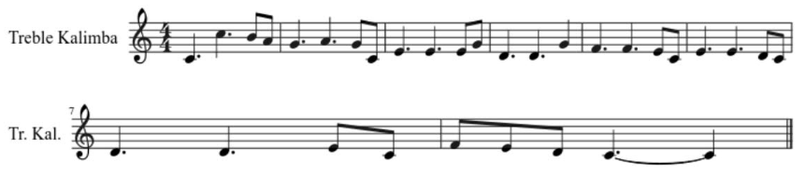
Phrase 1
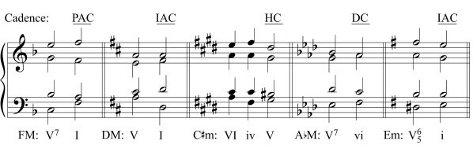
Phrase 2
